Barclay’s Hush LED Wall System User Guide

- Open Up Xpanel On one of the PCs (icon below) or go to the Touchscreen located on the AV Rack on Level9
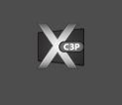

- This step is for Xpanel only, Xpanel uses SSL to connect with the processor so this screen will show up when it’s opened (For Touchpanel use, please go to Step 4):
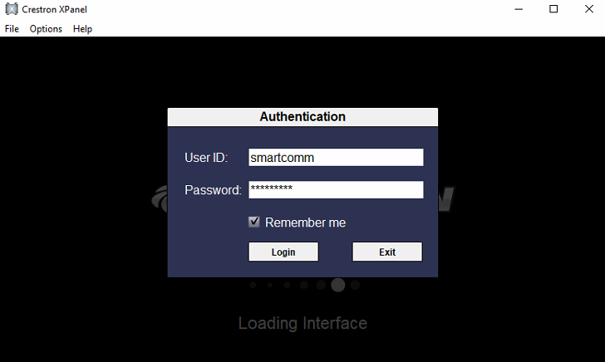
- Login details are filled in and remembered, but if for any reason they are lost, here are the details:
  - User ID: smartcomm
Password: 5m@rtc0mm

- Enter PIN Page
Default PIN (which is strongly recommended to be changed) is 1234
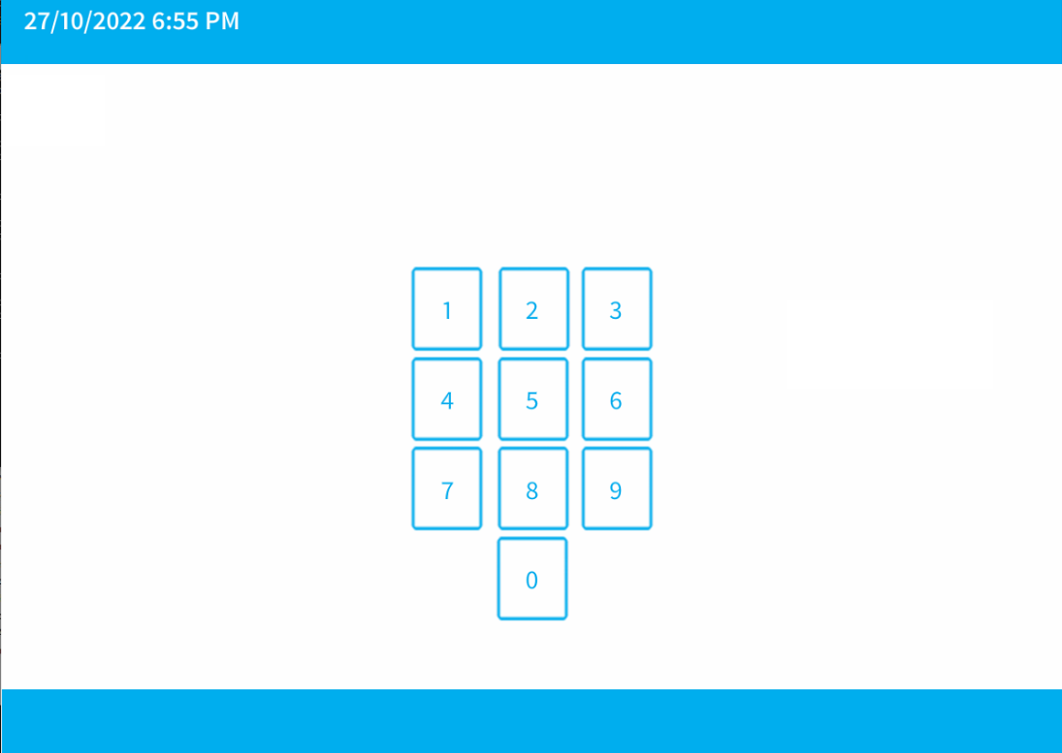
- Home Screen
After Logging in, if there is no activity after 5min, user will be logged out
3 Options Available
Scheduler - will open up a page to set up Screens On and Off Times
Blank Out Screens – will display two options to either blank out screens or cancel the operation
Admin – will open up a page which allows Video Matrix control or PIN Change
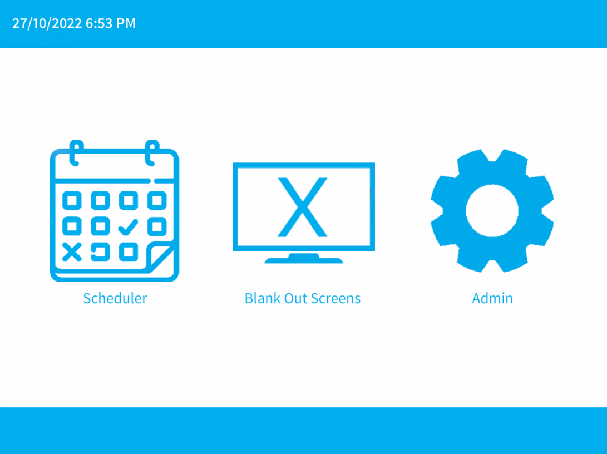

- Scheduler
When a day name is pressed (for Example Monday), a green tick will appear in the tick box
This means the Screens will go On and Off on that day, according to the selected times,
Each day has 24 options for On and Off times ranging from 00:00 – 23:00

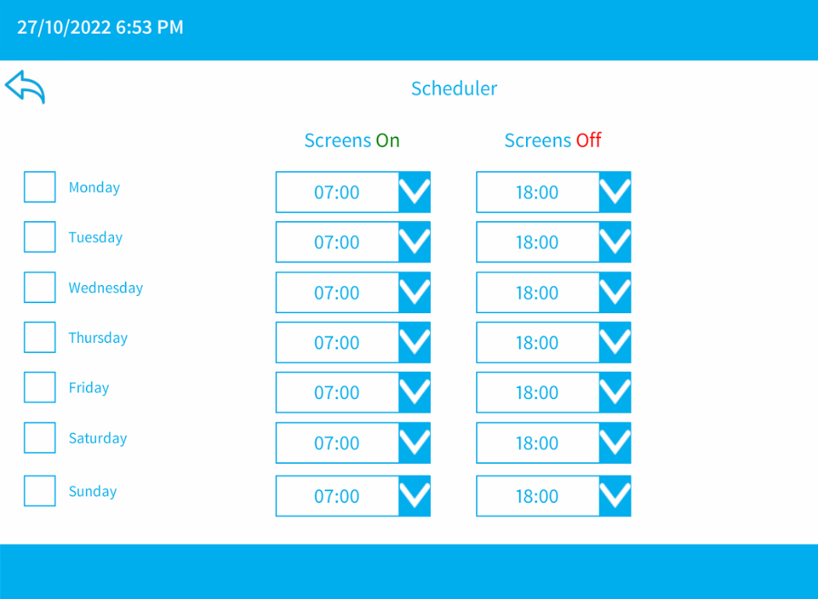
- Blank Out Screens
Two Options will appear, Confirm and Cancel
When Confirm is pressed, all four Video Walls will be blanked out
This can be confirmed on the Video Matrix Page by verifying that no output is selected
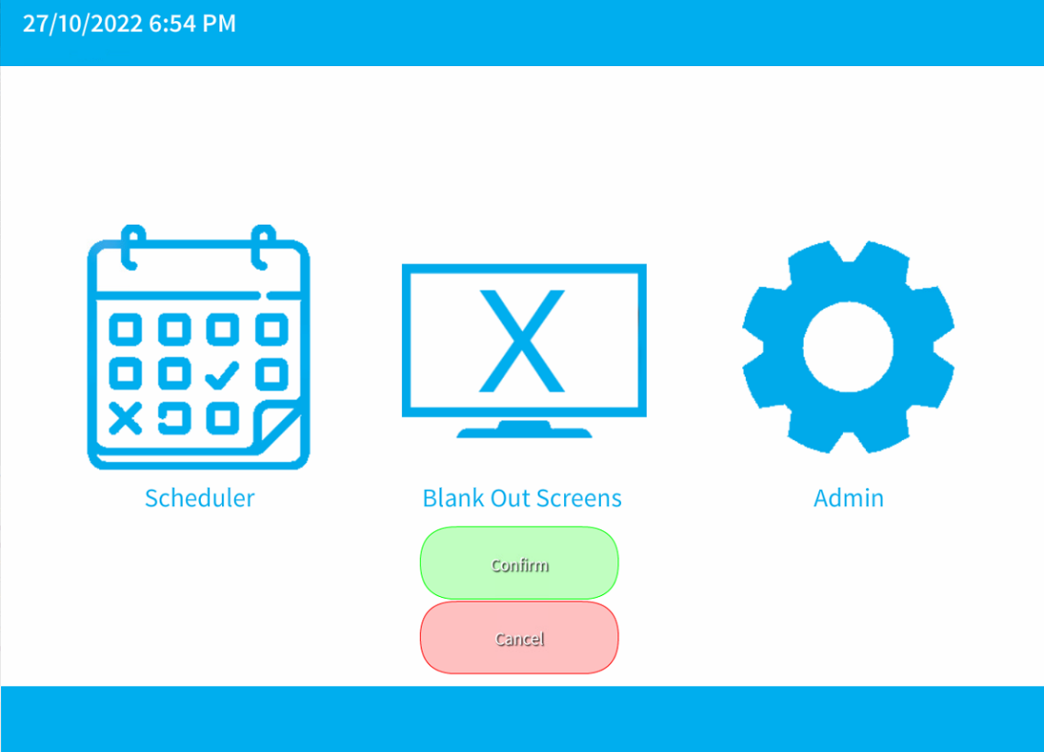

- Admin Page
Video Matrix – Manual Control – lets you manually route PC Outputs to any LED Wall
Change PIN – for use to change user PIN
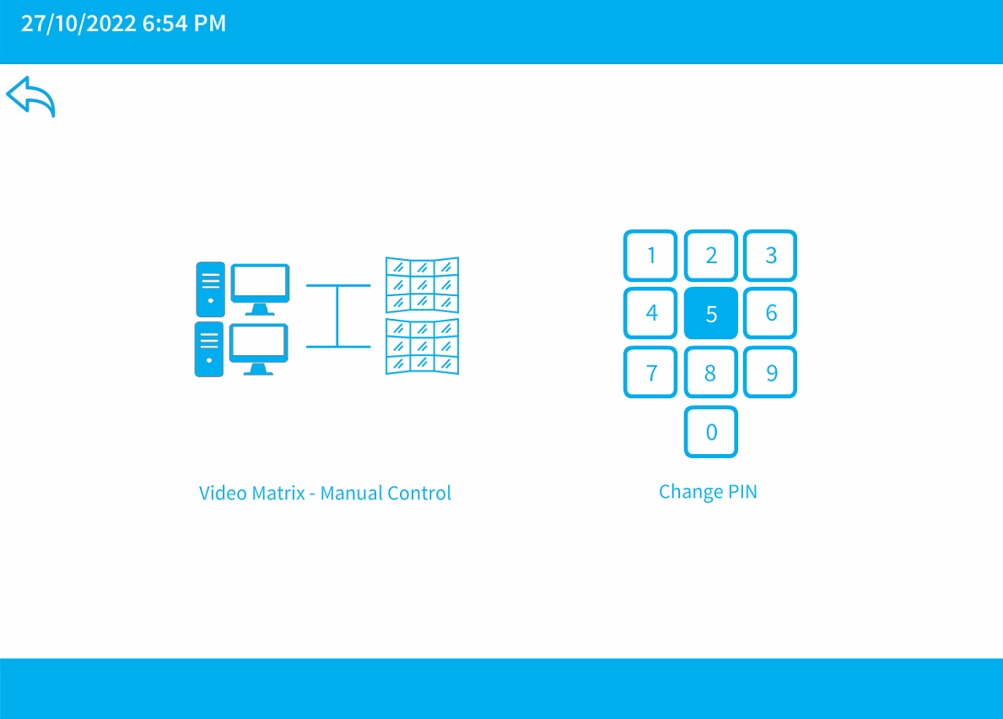
- Video Routing Page
Top Right shows connection status between the control system with the video matrix and each LED Wall
White Rectangles are used to route any PC Output to any LED Wall (CorioMaster)
Up and Down buttons control LED Wall brightness, which is displayed on a slider between them (Snowbox 1 - 4)
Controls will not work for equipment that shows as “Disconnected”
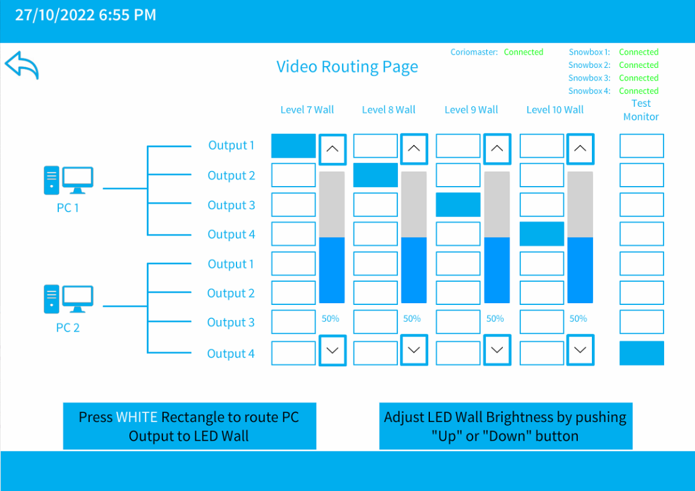
- Change PIN
When Changing Pin, User will need to enter their current PIN
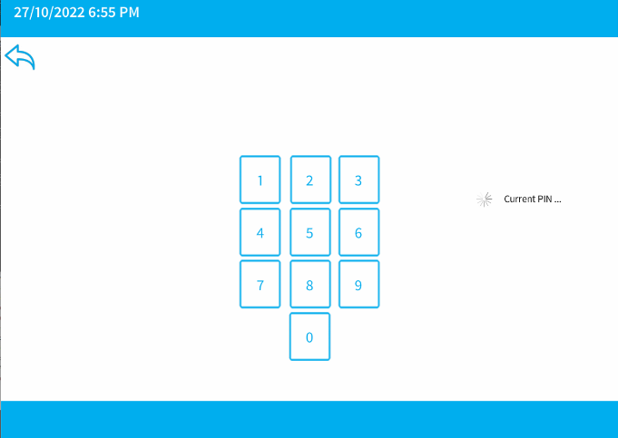
Followed by a new PIN
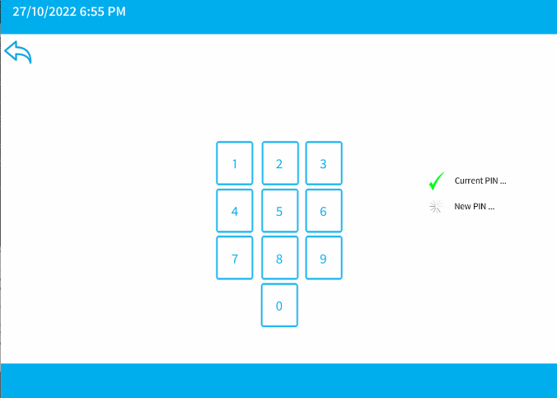
Followed by confirming their new PIN
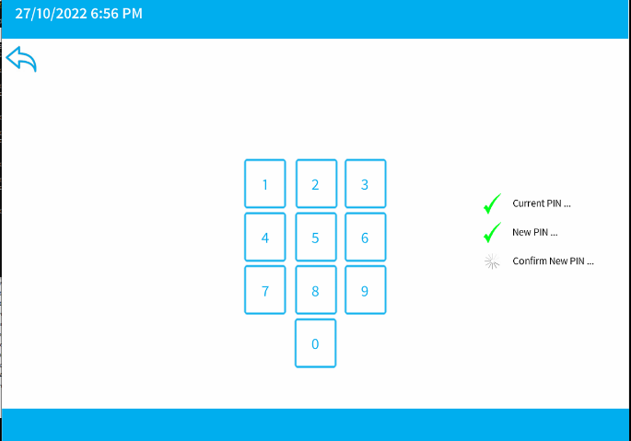
When done, User will be notified that PIN was changed and taken back to Home Page

